**Java Swing GUI Application for Data Input and Validation**

1. Initial state of the application when it's launched.

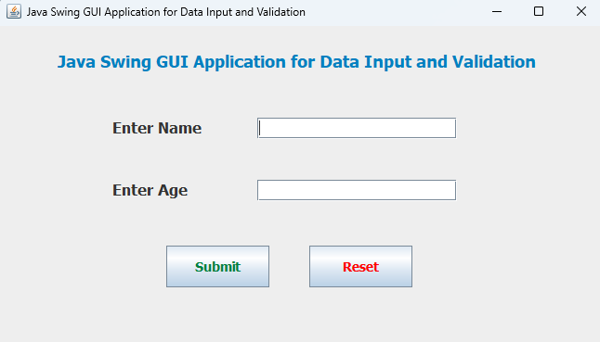

1. State when both fields are empty, and the "Submit" button is pressed.

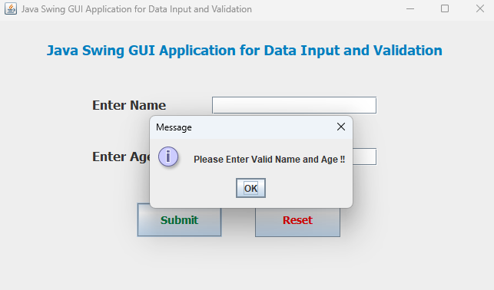

1. State when the name field is filled, but the age field is empty, and "Submit" is pressed.

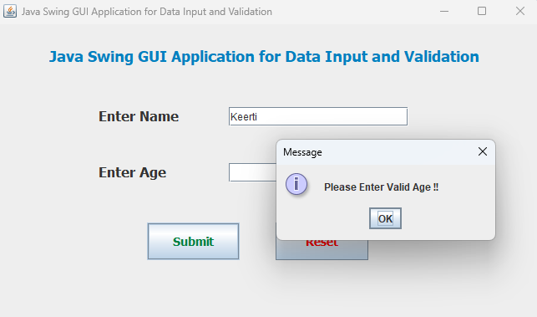

1. State when both fields are filled, and the age is 18 or more.

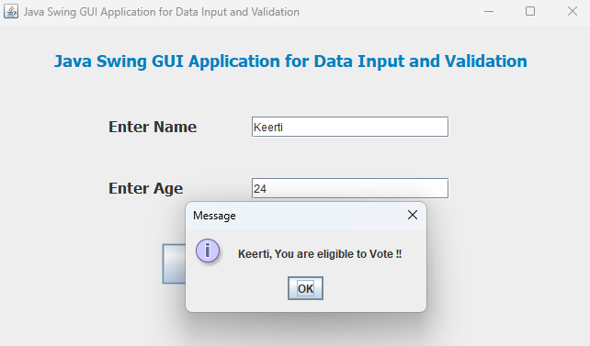

1. State when both fields are filled, and the age is less than 18.

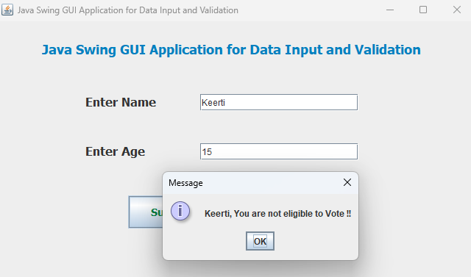

1. State when fields are reset using the "Reset" button.

